**SIT305 – Personalized Quiz App**

**Name: Sizhe Wang**

**Student ID: 223314413**

**Task 10.1D**

**GitHub repo:** [**https://github.com/AndyWanng/Deakin-SIT305-2024.git**](https://github.com/AndyWanng/Deakin-SIT305-2024.git)

**Demo video:** <https://deakin.au.panopto.com/Panopto/Pages/Viewer.aspx?id=77c1ae7f-610b-4701-a704-b16800d93c83>

**Introduction and Purpose**

The Personalized Quiz App is meticulously crafted to revolutionize the way users engage with educational content through quizzes. The app is developed to cater to learners who seek a personalized learning experience, offering quizzes across various topics including history, geography, science, and literature. The fundamental goal is to enhance user engagement through personalized content and to incorporate social learning dynamics, making learning an interactive and enjoyable experience.

**App Design and Development**

The app is developed using Android Studio, utilizing Java and XML for crafting a responsive and intuitive user interface. By adhering to the MVVM architectural pattern, the app ensures that the UI code is separated from the business logic, which enhances the maintainability and scalability of the application. The use of XML layouts facilitates a more organized and modular approach to UI design, allowing for easier adjustments and scalability.

**Key Features and Technologies**

1. **Dynamic Content Generation**
   * **LLM Integration**: Utilizing Large Language Models, the app dynamically generates quiz questions based on the selected topics. This ensures fresh and relevant content, keeping the user engaged and providing a customized learning journey.
   * **Smart Analytics**: Post-quiz analytics are powered by LLMs to give users insights into their performance, highlighting strengths and areas for improvement.
2. **User Management**
   * **Firebase Authentication**: Robust user authentication is handled via Firebase, ensuring secure access to user accounts and personalized data.
   * **Data Management**: Firebase also manages user data, storing quiz results and preferences securely in the cloud, which allows for seamless access across multiple devices.
3. **Enhanced User Experience**
   * **SmoothBottomBar**: This component enhances the navigation experience within the app, allowing users to seamlessly toggle between quizzes, analytics, and social features.
   * **Retrofit for Network Requests**: Ensures efficient data transmission between the app and backend servers, providing a smooth and responsive user experience.
4. **Social Integration**
   * **Sharing and Competitiveness**: Users can share their quiz results on social media, inviting friends to compete or collaborate, which integrates a social dimension into the learning process.

**Adherence to Modern Android Development Practices**

The development of the Personalized Quiz App follows best practices in Android development:

* **Use of Latest Android SDKs**: Ensures compatibility with a wide range of devices and access to the latest features from Android.
* **Responsive Design**: The app is designed to be fully responsive, providing an optimal experience across different device sizes and orientations.
* **Security**: Emphasis on security with Firebase’s built-in features for data handling and user authentication, ensuring that user data remains secure and private.

**Future Enhancements with LLMs**

* **Adaptive Learning Paths**: Future versions of the app could utilize LLMs to adapt quizzes based on user performance, creating a more tailored educational experience.
* **Voice Interaction**: Integration of voice-based question answering and interaction to make the app more accessible and engaging.
* **Natural Language Processing**: Enhanced NLP capabilities for analyzing open-ended responses, providing more depth to quizzes and analytics.

**Conclusion**

The Personalized Quiz App sets a new standard for educational apps by combining personalized content, robust architecture, and interactive features. By leveraging the power of LLMs, the app not only offers customized learning experiences but also scales new heights in smart analytics. Future enhancements are aimed at making learning even more adaptive and interactive, ensuring that the Personalized Quiz App remains at the forefront of educational technology.

**Screenshots:**

Flask server:

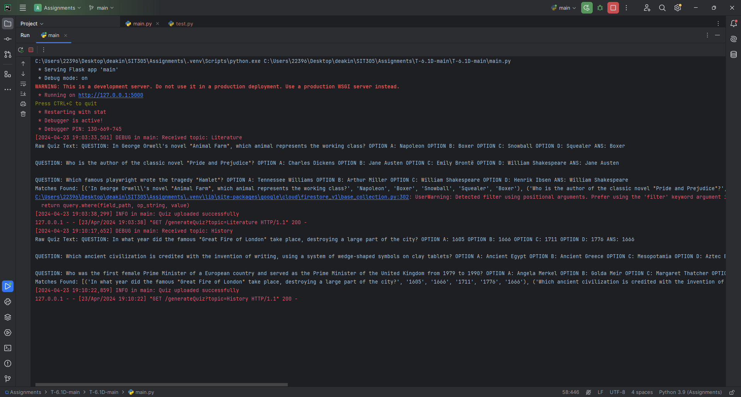

Personalized Quiz App:

Login and signup screen

Main screen (including topics)

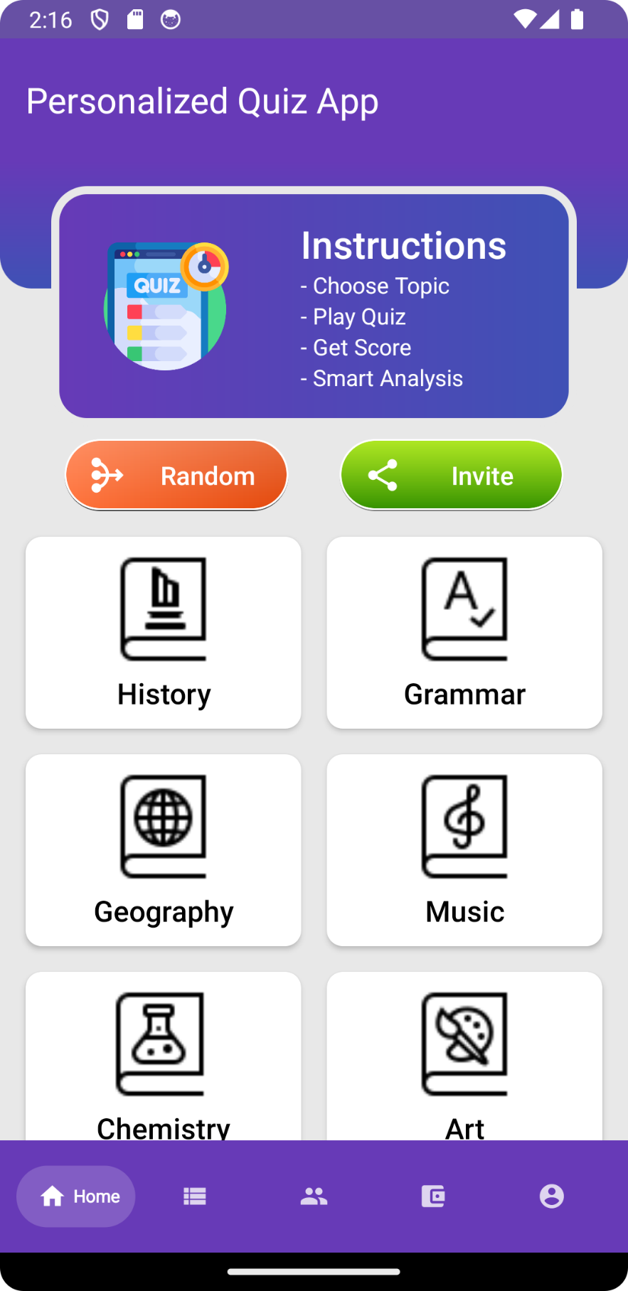

History screen(Quiz history)

History screen(Quiz details)

History screen(Quiz summary)

Payment screen

PayPal

Leaderboard screen

Profile screen

Quiz screen

